Mythology Today

MCj04351370000[1]

For this in class assignment you will find five examples of mythology being used in our world today. In the computer lab you will find five examples, obtain a picture for each example, write a description of the example and then state why that particular company or city or organization would want to use the mythology reference.

Requirements:

Five examples of mythology being used today

One picture for each of the five examples

One or two sentences describing the example

One or two sentences explaining why this reference is appropriate

Use this website as a guide:

<http://thanasis.com/modern/>

Example (you may not use this):

Venus Razor

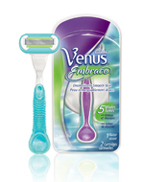

The Venus razor is a product from Gillette that also has commercials that state “Reveal the goddess in you.” Gillette would have chosen Venus as the name of their product because they want women to feel special by using their products and they do this by using a goddesses’ name.

25 points